INSERT COVER

This page left intentionally blank.
Administrative Handling Instructions

- The title of this document is [Title of Exercise] Tabletop Exercise (TTX) Situation Manual (SITMAN).
- The material provided in this report contains United States Department of Homeland Security (DHS) information that is unclassified. This document should be handled, transmitted, and stored in accordance with appropriate security directives governing protection and dissemination of such information. Reproduction of this document, in whole or in part, without prior approval from the [Fill in] is prohibited.
- For more information on this exercise, please use the following points of contact:

[Fill in]
[Sample below, Add information for the exercise development team leads]

Jeff Terry
County of Los Angeles
Office of Emergency Management
1275 N. Eastern Avenue
Los Angeles, CA 90063
jterry@ceooem.lacounty.gov
(323) 980-2259

Willdan/URS
Jim Bailey
Program Manager
Willdan Homeland Solutions
2401 East Katella Avenue, Suite 220
Anaheim, CA 92806
jbailey@willdan.com
(714) 940-6389

Lee Rosenberg
Project Manager
URS Corporation
1333 Broadway, Suite 800
Oakland, CA 94612-1924
Lee.Rosenberg@urs.com
(510) 874-3137

This page left intentionally blank.

Table of Contents

Exercise Schedule vi
Introduction 1
Exercise Overview 1
Purpose 1
Scope 1
Target Capabilities 1
Exercise Objectives 2
Participant Roles 2
Exercise Structure 3
Exercise Guidelines 3
Assumptions and Artificialities 4
Scenario 5
Key Scenario Points 6
Discussion Questions 12
Appendices 1
Appendix A – Acronyms/Glossary of Terms 1
Appendix B – References 1
Appendix C – Maps 1
Appendix D – List of Participating Agencies 1

This page left intentionally blank.

Exercise Schedule

[Date of Exercise]

[Edit times as appropriate]

Start | End | Description
8:00 | 8:30 | Registration
8:30 | 9:00 | Opening Remarks/Administrative Items
9:00 | 9:45 | Module #1- Objective 1
9:45 | 10:00 | Networking Break
10:00 | 11:30 | Module #2 - Objectives 2 & 3
11:30 | 12:00 | Participant Report Out/Hot Wash
12:00 | 12:15 | Closing Remarks / Next Steps
12:15 PM |  | Adjourn

This page left intentionally blank.

Introduction

Exercise Overview

Purpose [Sample Purpose]
The [Title of Exercise] TTX is designed to validate the [Name of Plan] and to review and discuss the County’s resource management strategies for a catastrophic earthquake response.

- The TTX will identify how resource management is done within any Operations Center
- The TTX will identify and promote discussion on an Operations Centers’ ability to manage commodity distribution operations.

Scope [Sample Scope]
The [Title of Exercise] TTX will include staff from [Participants] and will last [Duration] hours. The TTX will:
- Offer participants an opportunity to identify and discuss [Example] LACOA EOC and Operational Area (OA) response functions (as identified in the current LACOA Emergency Response Plan and EOC Standard Operating Guide) occurring in the initial hours after a major incident.
This TTX assumes a notional timeframe of “Event + 8 Hours.” [TTX discussions can be based on any notional timeframe to meet the objectives, i.e., initial response, recovery, during a shift change, etc.]

Target Capabilities
The DHS has adopted capabilities-based planning and exercises as a means of achieving the Preparedness Goal. Resource allocation will be linked to capabilities that affected stakeholders most urgently need for a range of assigned missions and tasks. Currently, there are 37 capabilities identified.

The [Title of Exercise] TTX is a capabilities-based exercise. This means that the exercise objectives that the exercise planning committee selected are based on capabilities that the committee and local operators mutually agreed to examine, in whole or in part, during this TTX. The exercise planning committee selected exercise objectives that are linked to the following capabilities from the Target Capabilities List [Examples or insert new Target Capabilities as appropriate]:
- EOC Management
- Critical Resource Logistics and Distribution
- Intelligence and Information Sharing and Dissemination
Capabilities are divided into groups of activities, which are then subdivided into tasks. Successful completion of the majority of tasks will demonstrate completion of the activity, and successful completion of the activities will demonstrate the extent to which a jurisdiction is able to demonstrate a capability.

In the discussion-based portion of the [Title of Exercise] TTX, the exercise objectives are linked to the appropriate activities under the capability. The TTX participants will discuss, but not perform physical or actual tasks. For evaluation purposes, evaluators will focus on the discussions at the activity-level, including the tasks under that activity that participants might discuss during the exercise.

Exercise Objectives
[Sample Objectives or insert new objectives as appropriate]
[Corresponding Capabilities are listed after the Objective in parenthesis]
Within the capabilities shown above, the TTX will encompass the following objectives:

Objective 1: In response to activation for a catastrophic earthquake, discuss the OA’s EOC and Department Operations Center (DOC) protocols and processes for activating and operating the operations center. Analyze processes for coordination vertically with local jurisdictions and the State, and horizontally with other County agencies for organizing an integrated resource management system within the County (EOC Management).

Objective 2: In response to a catastrophic earthquake, discuss the protocols and processes for activating and operating commodity points of distribution (C-PODs) in a coordinated manner throughout the OA (Critical Resource Logistics and Distribution).

Objective 3: Discuss how critical resource requirements information is identified, gathered, and entered into information management systems and shared as appropriate (horizontal and vertical information sharing). Identify primary and redundant County protocols for compiling resource requests after a catastrophic earthquake (Intelligence and Information Sharing and Dissemination).

Participant Roles
- Participants respond to the situation presented based on expert knowledge of response procedures, current plans, and procedures.
- Subject-Matter Experts (SMEs) may be consulted by players during exercise play, but are usually not included in the discussion points.
- Facilitators provide situation updates and moderate discussions. They also provide additional information or resolve questions as required.
- Observers may watch the various groups as they discuss and develop responses to the situation. They may not interact with players at any time during exercise play.

Exercise Structure

The [Title of Exercise] TTX is a facilitated, discussion-based exercise. Participants will discuss issues regarding resource management following a catastrophic event. The scenario and discussion questions will focus on the eight hours immediately following an earthquake.

The discussions will begin with a situation briefing or update presented to the players. Following the briefing, players will participate in a facilitated discussion focused on action planning and response operations. Each exercise participant will receive a copy of this SITMAN, which provides a written storyline to accompany presented situation updates. Participants are encouraged to use their SITMAN, as well as all appropriate plans, policies, and procedures as references throughout the exercise.
[Change graphic as appropriate]
Observations and recommendations from this TTX will be incorporated into the [Title of Exercise] Tabletop After-Action Report/Improvement Plan (AAR/IP). An AAR/IP captures discussions/events during an exercise, provide analysis of the issues relative to exercise objectives, and suggest development actions to either enhance or improve agency/jurisdiction planning and response capabilities. It also evaluates achievement of the selected exercise objectives and validates the overall capabilities.

The Improvement Plan (IP) portion of the AAR/IP includes corrective actions for improvement, along with timelines for their implementation and assignment to responsible parties. Once recommendations, corrective actions, responsibilities, and due dates are identified in the IP, the appropriate stakeholders ensure that each corrective action is tracked to completion. Stakeholders review all exercise evaluation feedback and resulting IPs to assess progress on enhancing preparedness. This analysis and information are incorporated into the capabilities-based planning process because they may identify needs for additional equipment, training, exercises, coordination, plans, or procedures that future exercises can validate. Continual IP tracking and implementation should be part of a corrective action program within each participating entity.

Exercise Guidelines
The following guidelines will apply during the exercise:
- This is an open, low-stress, no-fault environment. Varying viewpoints, even disagreements, are expected.
- Participate based on your knowledge of current plans and capabilities, and any insights derived from training (i.e. you may use only existing assets).
- Decisions are not precedent setting and may not reflect your organization’s final position on a given issue. This is an opportunity to discuss and present multiple options and possible solutions.
- Assume cooperation and support from other responders and agencies.
- Issue identification is not as valuable as suggestions and recommended actions that could improve response and preparedness efforts. Problem-solving efforts should be the focus.

Assumptions and Artificialities

[Example] A number of assumptions and artificialities may be necessary to complete play in the time allotted. During this exercise, the following apply:
- The scenario, taken from the 2008 ShakeOut Scenario, is plausible, and events occur as they are presented.
- There are no “hidden agendas” or trick questions intended to mislead participants.
- All participants receive information at the same time.
- Participants should assume that all agencies are responding appropriately based on available plans, procedures, and protocols.

Scenario

1:15 a.m., Tuesday, February 26, 2013 [Change time and date as appropriate]

[Use this paragraph for a daytime event] It is sunny with a light breeze. Fortunately, today there are no Santa Ana winds. Rush hour traffic is still in force, and the workday is underway in offices, warehouses, factories, and stores. Many of the older buildings and even a few newer ones are constructed in ways that make them vulnerable to earthquake shaking. Schools are full of students, as well as furniture and equipment that will topple in an earthquake and heavy objects that will become airborne.

[Use this paragraph for a night-time] It has been a still night. Fortunately, there are no Santa Ana winds. The San Andreas Fault suddenly awakens, and the rupture shoots along the fault at two miles per second, sending seismic energy waves out in all directions. In an instant, the earthquake offsets the ground on the two sides of the fault by nearly 44 feet.

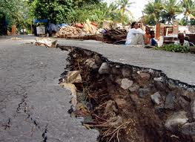
As the earthquake’s rupture front travels up the fault, it sends out seismic waves that shake the ground, collapsing buildings, shutting down power systems, rupturing water mains, cracking roadways, causing landslides, and igniting fires. Older buildings collapse completely or sustain structural damage. Unreinforced masonry buildings crumble into debris piles, trapping occupants. The rupture front continues its advance and dismantles the 10 miles of I-10 freeway that straddle the San Andreas Fault.

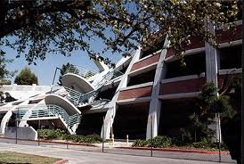
Within seconds, the first waves have severed the I-15 freeway, bent rail lines, and deranged linear critical infrastructure systems. Roads that had passed across the fault now end abruptly at a 15-foot chasm. The strong shaking also triggers landslides across the rails and roads. The earthquake snaps pipelines and critically damages electrical transmission lines, causing widespread utility service interruption.
Strong shaking reverberates in the sediment-filled basins throughout the OA. Buildings that have collapsed or shifted off their foundations break gas and water lines in the process.

The strong, prolonged shaking heavily damages or collapses many wood-frame buildings, and even a few, new high-rise steel buildings. The building damage causes tens of thousands of injuries and hundreds of deaths, and leaves hundreds of thousands of people stranded and without homes.

Buried in the sediment are the water and sewer pipes that sustain the cities within the OA. Many of these pipes crack when earthquake waves deform the ground. In modern homes, the earthquake will primarily damage its contents. Kitchen floors disappear under heaps of cooking oil, syrup, flour, and smashed dishes, but there is no tap water to start cleaning.

Power is out, so traffic lights are dark and electric trains are suddenly immobilized. While traffic is minimal at this time of night, buses, cars, and trucks quickly become gridlocked. Eventually, many drivers will abandon their cars and not look back as they begin the long walk home, perhaps envied only by a few people sitting in the dark, awaiting rescue from stalled and stifling elevators.

Across Southern California, the power is out. Emergency generators that building personnel have secured against earthquake shaking are still functional, and are kicking on. The shaking has finally stopped—but the aftershocks are just beginning.

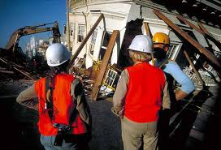
The State highway system has fared well. A $6 billion investment in seismic retrofitting has paid off, and the only highway deaths have been in crashes caused by intense earthquake shaking. However, the long duration of shaking has taken its toll on bridges and overpasses in local jurisdictions, where jurisdictions have not yet completed the retrofitting process, or have not yet begun.

No Los Angeles area hospitals have seen complete collapses, but many hospital buildings are nonfunctional. Some hospital structures survived the shaking, but must close due to nonstructural damage, such as water pipes that break, resulting in flooding.

Key Scenario Points

Discussions begin at Event + 8 Hours.

- The earthquake does not generate a tsunami, despite its magnitude.
- The rest of California and the Nation will face the daunting task of responding to effects on the population, economic disruption, and media attention.
- Threats and hazards resulting from shaking, surface fault rupture, and liquefaction include:
  - Structural and nonstructural damage to buildings and infrastructure, including widespread collapse of buildings
  - Widespread fires
  - Subsidence and loss of soil-bearing capacity, particularly in areas of liquefaction
  - Displacement along the San Andreas fault
  - Widespread landslides
  - Hazardous materials spills and incidents
  - Dam/levee failure resulting in flooding
  - Civil disorder
- Threats and hazards resulting from the main earthquake are aggravated or recur during aftershocks, which continue for months after the main earthquake.
- Within the first 8 hours:
  - County Chief Administrative Officers proclaim local emergencies.
  - The Governor proclaims a State of Emergency and requests that the President declare a disaster.
  - The President declares a Major Disaster, making Federal assistance available under the Robert T. Stafford Disaster Relief and Emergency Assistance Act of 1988 (42 U.S.C. §§ 5121–5206 [2008]) (the Stafford Act).
  - DHS and FEMA implement the Catastrophic Incident Supplement to the National Response Framework and begin mobilizing Federal resources.
  - DHS activates or elevates the level of activation of all DHS command and coordinating facilities.
- OA EOCs experience some damage but are at least partially operational. All other local jurisdiction functions in the OAs are severely compromised or focused entirely on response to the earthquake.
- Response capabilities and resources of the local jurisdictions, OAs, and the State are quickly overwhelmed or exhausted.
- OA EOCs are overwhelmed and challenged to manage the OA response effectively.
- Emergency workers cannot achieve a detailed and credible common operating picture for 24 to 48 hours (or longer) after the disaster. As a result, response activities begin without the benefit of a detailed and complete situation or critical needs assessment.
- The disaster personally affects first responders, recovery services providers, and other critical response personnel and may be unable to report to their posts for days because of damaged transportation infrastructure.
- Once the President declares a disaster and commits Federal resources, the State and Federal governments establish joint operations to provide assistance to local jurisdictions.
- Massive assistance in the form of response teams, equipment, materials, and volunteers begin to flow towards the region, providing urgently needed resources but creating coordination and logistical support challenges.
- Due to transportation infrastructure damage, out-of-region mutual aid, State, and Federal resources, as well as resources from other states cannot begin to arrive for up to 72 hours after the event.
Regional Earthquake Effects

The earthquake is a magnitude 7.8 earthquake on the southernmost 300 km (200 mi) of the San Andreas Fault, between the Salton Sea and Lake Hughes. The southern San Andreas Fault was identified in the most recent assessment of seismic risk as most likely source of a very large earthquake in California. The earthquake’s regional effects are listed below:

- 7.8 Magnitude earthquake
- 1,800 deaths
- 53,000 injuries requiring emergency room treatment
- 300,000 buildings significantly damaged (1 in 16 buildings)
- 1,600 ignitions requiring a fire engine, 1,200 exceed capability of the first engine. In areas of dense wood-framed construction, these fires, if not controlled, will grow quickly to involve tens or hundreds of city blocks. Fires will have accounted for 885 deaths and $90 billion in property losses
- Electrical, potable water, wastewater, and telecommunications utilities are damaged and inoperative.
- Transportation networks are disrupted
- 542,000 individuals require shelter, to include those with access and functional needs. This includes over 50,000 toddlers and infants
- 2.5 million individuals shelter-in-place and need basic resource support (e.g., food, water, ice)
- 267,000 displaced household pets
- 4,500 rescues
- $213 billion damages

Operational Area Earthquake Effects

The earthquakes operational area effects are listed below:

- ~39,000 buildings damaged; ~4,500 beyond repair. Essential facilities are structurally sound.
- ~1,500 displaced households
- 3,400 injuries and 42 deaths
- Transportation systems do not sustain significant damage
- Utility systems and other critical lifelines are heavily damaged and require inspections and extensive repairs

Operational Area Resource Management Effects

- Fuel – Crippling impacts will occur to fuel refining, distribution, and point of sales facilities. Refineries and tank farms may catch fire and burn for many days. Point of sales and fleet fuel facilities will be unable to dispense fuel until electric power is restored. Fuel will be a critical, priority resource requirement for all response operations. The earthquake will damage the following:
  - Refining facilities, including crude oil marine terminals
  - Tank farms and other storage facilities
  - Pipelines and other fuel distribution facilities
  - Local government fuel facilities and commercial retail operations
  - In areas without electricity, loss of power and internet connectivity will prevent fuel from being dispensed except where emergency generator power is available
  - Transportation agencies and city agency fleets generally have one to three days of fuel on hand.
- Water – Much of the water for the LACOA comes from out of the area. Aqueducts and pipes supplying this water cross the fault may fail. Ground water wells may be inoperative due to loss of electric power. Additionally, ground water may be contaminated from toxic spills. Potable water supply systems sustain major damage because of the following:
  - Extensive damage to pipelines from ground deformation
  - Interruption of pumps and treatment due to power outages
  - Damage to treatment facilities, storage facilities, and distribution infrastructure
  - Contamination of potable water systems because of damaged lines
- Food – Many households have not stored sufficient supplies of nonperishable food necessary to sustain life until utility crews restore power and water are restored and food distribution systems have been reestablished. The following list provides the personnel impacts and potential programs that will likely result from the damaged food system:
  - Significant impacts to the food supply chain due to damage to grocery stores, warehouses, and food distribution centers, in combination with disruptions to the regional transportation system, will limit the amount of food available.
  - Disaster service workers will need food and water in order to respond effectively and continue operations.
  - Local jurisdictions will establish initial feeding programs that include packaged food such as Meals, Ready-to-Eat (MREs) and Heater Meals, but will expand to include warm, prepared food as mobile kitchens are established.
- Sanitation – Wastewater/sanitation systems will be inoperative due to lack of power, damage to treatment plants, and damage to wastewater collection and pumping systems. Restoration and repairs will require weeks. The need for portable/temporary sanitation systems will be critical to preserve public health. The following list provides the personnel impacts and potential programs that will likely result from the damaged wastewater system:
  - A small percentage of the population will remain in the impacted areas after the recommendations/orders for evacuation, and will need to be supported with sanitation.
  - Portable toilets, hand washing stations, and portable showers will be required to support response personnel and sheltering populations.
- Ports – Port facilities will suffer minimal damage and should be functional within three days as utility crews restore electric power. The earthquake will render rail lines impassable by the fault offsets and ground motions, reducing or eliminating the ability to move cargo or freight through these facilities. Significant economic disruption will result and the extent of the economic damage depends on how rapidly the railways and highways can be rebuilt following.
- Airports – The earthquake will cause moderate damage to LAX, Ontario airports, and regional facilities such as Burbank, Van Nuys and Long Beach airports.
  - Airport operations, including passenger-plane runways, lighting, terminal facilities, control towers, terminal buildings, cargo handling facilities, and access roads, will likely sustain earthquake damage and could be inoperable for 15 days or more.
  - Initially, affected airports will be available only to small, fixed-wing, and rotary aircraft. Air operational capability for large, fixed-wing aircraft may resume within one week, but many of the fueling, servicing, and cargo-handling facilities will not be operational for a longer period.
  - Passenger operations may be delayed for five days or more.

This page left intentionally blank.

Discussion Questions
These questions serve as a guide to facilitate discussions to meet the exercise objectives. The facilitator may or may not utilize all of the questions within the time allotted.

[If using different Objectives, copy Objective 1 from Exercise Overview section]
Objective 1: In response to activation for a catastrophic earthquake, discuss the OA’s EOC and DOC protocols and processes for activating and operating the operations center. Analyze processes for coordination vertically with local jurisdictions and the State, and horizontally with other County agencies for organizing an integrated resource management system within the County (EOC Management).

Essential EOC staff has been frantically working for eight hours. Many first and second shift staff left the EOC facility after the initial shake to locate and care for family members. Of those, a number have not returned. Second shift staff that remained, were told to rest at the EOC facility or return for a shift change at 8 p.m.

    - What actions has your jurisdiction/agency taken to create a provisioning plan and establish a dormitory for essential EOC/DOC staff who are unable to return to their homes? Does it include sanitation supplies?
    - Does your jurisdiction/agency have a plan to determine the well-being of essential EOC/DOC staff family members so that the staff are comfortable and able to focus on emergency response? Does the EOC have a family member hotline or webpage to provide/collect information to keep essential staff and their families informed?
    - If the scenario event occurred outside normal working hours, does your jurisdiction/agency have automated/redundant notification/recall systems for essential staff? Has your jurisdiction/agency identified the first-in staff who will initially open EOC operations?
    - Does your EOC/DOC have an emergency generator that provides both normal electric power and supports HVAC systems? How many hours of fuel does the emergency generator tank contain? In this scenario, will your EOD/DOC be able to acquire more fuel before the emergency generator flames out? How often is the emergency generator tested for automatic operation?

Notes
C-PODs are centralized locations where the public picks up life sustaining commodities following a disaster or emergency. Please note that all discussions of PODs during this exercise refer to Commodity Points of Distribution (C-PODs).

Commodities provided can include, but are not limited to, shelf stable food, bottled water, and limited amounts of ice, tarps, and blankets.

Notes

This page left intentionally blank.
[If using different Objectives, copy Objective 2 from Exercise Overview section]
Objective 2: In response to a catastrophic earthquake, discuss the protocols and processes for activating and operating C-PODs in a coordinated manner throughout the OA (Critical Resource Logistics and Distribution).

Due to damage to transportation infrastructure systems, large quantities of commodities and response resource from out of the region will take 72 hours to arrive. During that time, the OA and local jurisdictions must determine their resource requirements, initiate orders and requests and prepare to receive and distribute inbound resources.

- What Standard Operating Procedures (SOPs) are in place for ordering and acquiring resources and services?
- How are requests for resources received?
- How are requests for resources prioritized?
- What are the procedures for identifying, activating and establishing for Local Staging Areas (LSAs) for inbound equipment and supplies?
- How are resources received and tracked?
- How will commodity distribution address access and functional needs (AFN) populations?
- Identify the locations of the local C-PODs, if any exist in your jurisdiction. Are they adequate for the scenario incident? Have agreements been put in place with the property owners? Do other plans exist to use the property for another purpose that would conflict with its use as a C-POD?
- How are C-PODs activated and established?
- Who is responsible for staffing/operating the C-PODs? Is this identified in your plans?
- How are inaccessible pre-identified C-POD locations addressed?
- Are their provisions for activating pedestrian C-PODs?
- How will commodity distribution address AFN populations?
- How does the local jurisdiction determine the quantities and types of critical commodities needed to support affected populations?
- Based on the scenario, are current spending caps for goods and services sufficient? Discuss the protocols for raising the spending caps if the situation arises.
- Describe the protocols for providing ongoing strategy or status updates to illustrate resource priorities and processes.
- Does your logistics plan include public-private partnerships?
- How do your local jurisdiction’s plans address transporting materials through restricted areas?

Notes

Notes

This page left intentionally blank.
[If using different Objectives, copy Objective 3 from Exercise Overview section]
Objective 3: Discuss how critical resource requirements information is identified, gathered, and entered into information management systems and shared as appropriate (horizontal and vertical information sharing). Identify primary and redundant County protocols for compiling resource requests after a catastrophic earthquake (Intelligence and Information Sharing and Dissemination).

Situational awareness of the extent of damage and the locations and degree of severity of individual incidents is just beginning to emerge. Immediate priorities are identifying the boundaries of fires in order to respond to them and determining locations of people trapped in structures or exposed to hazardous conditions.

- How does the EOC/DOC collect, organize, display, and share information to provide situational awareness of resource requirements and management operations among County agencies and between the OA, and the local jurisdictions and the Cal EMA regional emergency operations center (REOC)?
- Does your agency Emergency Operations Plan (EOP) / EOC SOP contain an incident information collection plan or procedures that address analysis of resource requirements? What should such a plan contain? Has appropriate agency staff been trained to use the plan?
- Does your jurisdiction have a damage assessment plan to determine impacts to critical lifeline infrastructure? Does the plan permit integration of local, state, National Guard, private, and not-for-profit resources? How is information on the status of and the impacts resulting from damage to critical lifeline infrastructure collected, analyzed, and exchanged?
- Does your jurisdiction/agency have the ability to display information using web-based Geographic Information System (GIS) (e.g., maps, photos)? Does staff in the Planning Section have adequate training to use these systems?
- Describe data display/management systems available in your EOC/DOC.
- Describe how you share information in your EOC so that everyone has situational awareness.
- Describe the procedure for obtaining and maintaining situational awareness of the area’s available transportation routes.
- Describe the procedure or template to assist in proactively disseminating resource management priorities and strategies to your community.

Notes

Notes

This page left intentionally blank.

Appendices

Appendix A – Acronyms/Glossary of Terms
[Update as required]

AAR/IP | After-Action Report/Improvement Plan
AFN | Access and Functional Needs
C-POD | Commodity Point of Distribution
DHS | United States Department of Homeland Security
DOC | Department Operations Center
EEG | Exercise Evaluation Guide
EOC | Emergency Operations Center
EOP | Emergency Operations Plan
GIS | Geographic Information System
HSEEP | Homeland Security Exercise and Evaluation Program
HVAC | Heating, Ventilation and Air Conditioning
ICS | Incident Command System
IP | Improvement Plan
LACOA | Los Angeles County Operational Area
LAX | Los Angeles International Airport
LSA | Local Staging Area
MRE | Meal Ready to Eat
OA | Operational Area
OEM | Office of Emergency Management
REOC | Regional Emergency Operations Center
POD | Point of Distribution
SEMS | Standardized Emergency Management System
SITMAN | Situation Manual
SME | Subject Matter Expert
SOP | Standard Operating Procedure
TTX | Tabletop Exercise

This page left intentionally blank.

Appendix B – References

FEMA IS-26 Guide to Points of Distribution

Course Overview

This guide was developed to support the Points of Distribution (POD) overview video and provide an in depth look into the planning, operations, and demobilization stages of a POD mission. The lessons detail the staffing and procedures any jurisdiction will need to plan for, execute, and shut down POD operations. The guide also includes key lessons such as safety, equipment, and resource accountability and informs the reader about the Adopt a POD program being used by the state of Washington.

Course Objectives
By the end of reading this Guide you will be able to:

- Describe PODs
- Explain how PODs are set up and operated
- Understand how to supervise a POD staff

This course can be found at the website: http://training.fema.gov/EMIWeb/IS/is26.asp
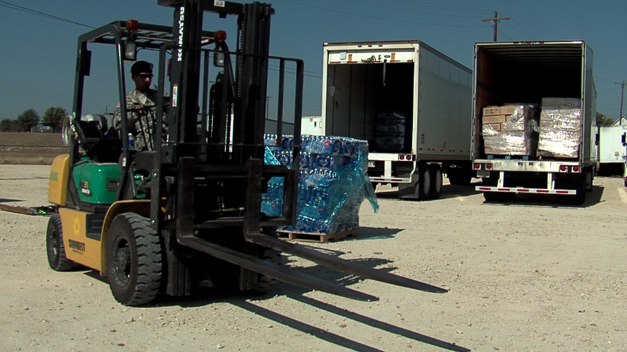

This page left intentionally blank.

Appendix C – Maps

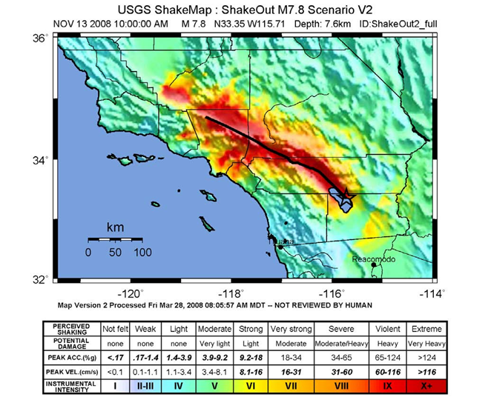

This page left intentionally blank.

Appendix D – List of Participating Agencies

[Update as required]

This page left intentionally blank.

